Network Scanning & Enumeration Report
By : Devanarayan Sunil

Executive Summary
This network scanning and enumeration assessment was conducted to identify exposed network services, open ports and potential attack surfaces of a target system. Using industry standard tools such as Nmap and Netcat, the assessment focused of understanding the network footprint of the target and identifying services that could be leveraged by the attacker, The results highlight multiple open ports and running services which, if left unsecured, may increase ethe risk of unauthorized access and exploitation.

Scope
The scope of the report was limited to network-level scanning and enumeration of target system. The Steps included host discovery, TCP port scanning, service and version identification and basic operating system detection. No active exploitation was performed as part of this test. All testing was concluded in a controlled and authorized environment.
Target: Metasploitable2
Testing Type: Network Scanning and Enumeration
Tools: Nmap, Netcat

Methodology
The assessment followed a structured approach beginning with host discovery to confirm target availability. This was followed by port scanning to identify open TCP ports. Service and version detection were performed to enumerate running applications and their versions. Operating system fingerprinting and default script scans were conducted to gather additional information about the target configuration. The tools used during this assessment included Nmap for scanning and Netcat for basic interaction and banner grabbing.

Findings
The network scan revealed multiple open ports exposing services such as FTP, SSH, HTTP etc. Service version detection indicated the presence of outdated software versions that may contain known security vulnerabilities. The availability of multiple externally accessible services increases the overall attack surface of the system, making it a potential target for further exploitation if appropriate security controls are not implemented.

Proof Of Concept
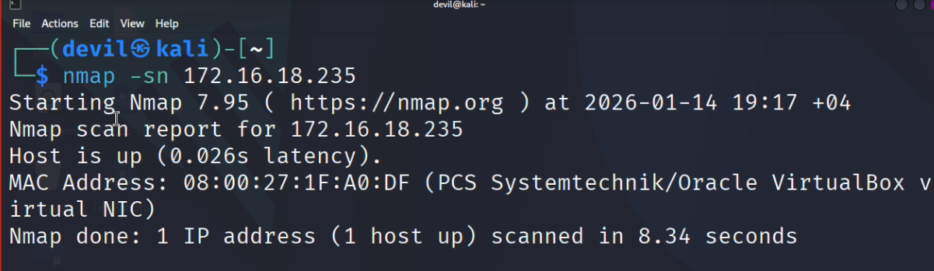
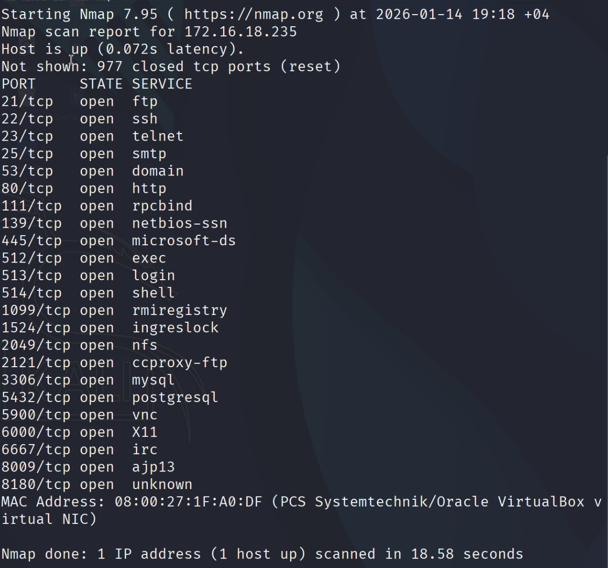
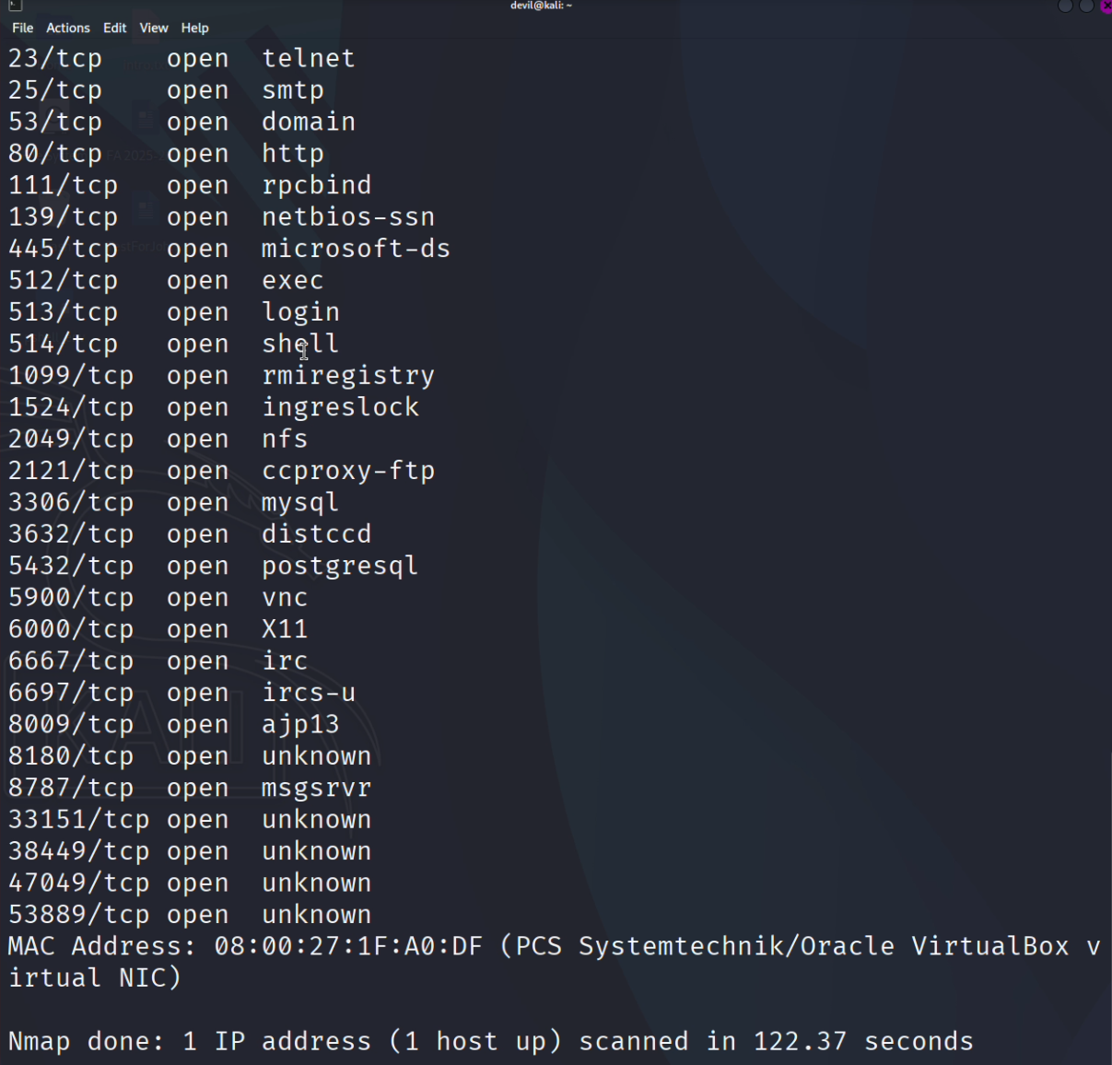
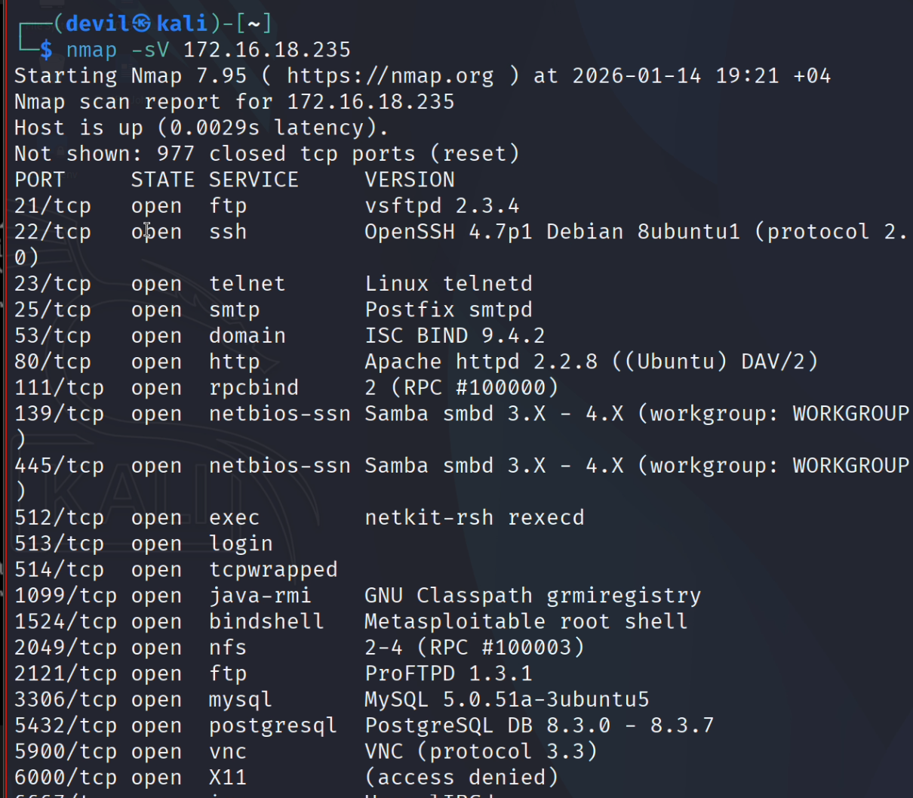
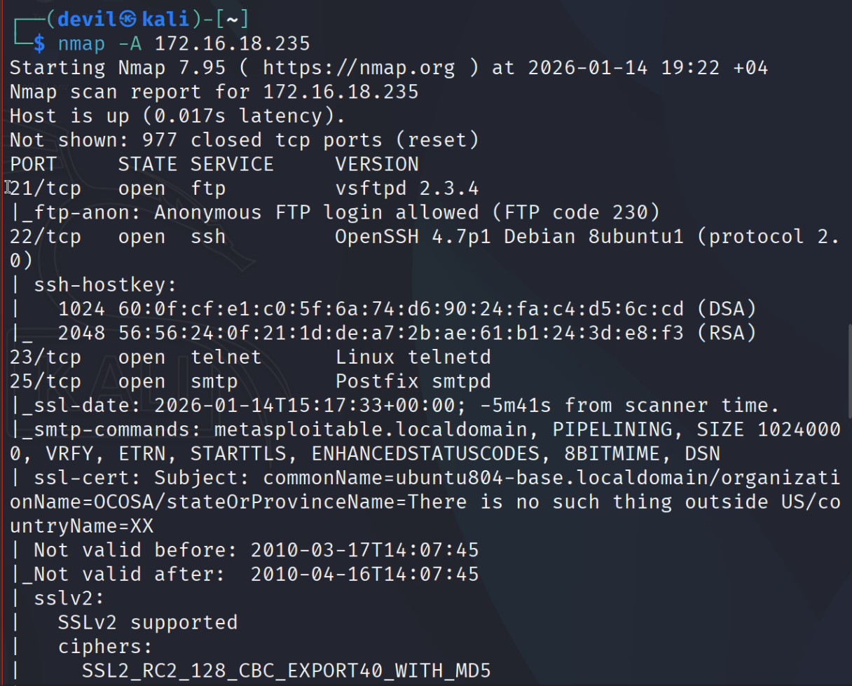
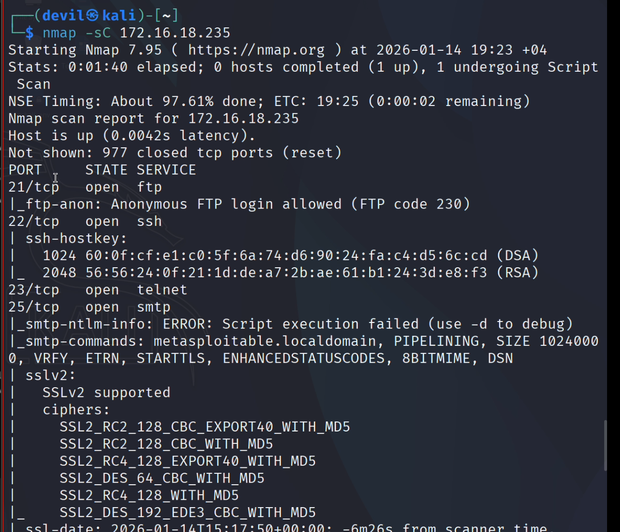
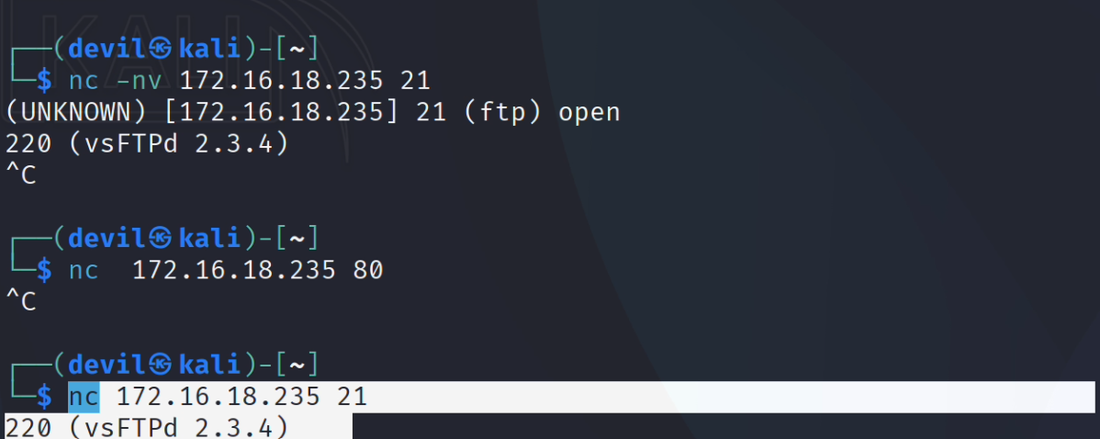

Conclusion
The network scanning and enumeration activities successfully identified exposed services and highlighted potential security risks associated with the target system. While no exploitation was performed, the findings demonstrate the importance of minimizing open ports, updating services and implementing proper network security controls. Addressing these issues significantly reduces the attack surface and improves the overall security posture of the system.

